Olivier Mattmann, COLIN FINGERLIN, MATíAS carballo González

[Company address]

NES-EMULATOR

CAOS-PROJECT

# Table of Contents

INHALTSVERZEICHNIS Error! Bookmark not defined.

HARDWARE 2

CPU 2

Beschreibung **Error! Bookmark not defined.**

APU 4

Beschreibung 4

PPU 4

Memory 4

Bus 4

# HARDWARE

The NES console is made up of the CPU, the APU (Audio Processing Unit), the PPU (Picture Processing Unit), a total 4kB of RAM, and of course the ROM on the game cartridge. These components communicate with each other using Buses, and are also made up of multiple subcomponents.

## 

## CPU

### Description

The CPU is a 6502 microprocessor, that runs with a **Clockspeed of 1,79MHz**. The CPU has 6 Register und 6 used Flags, that are described below.

|  |  |  |
| --- | --- | --- |
| **Register** | **Size** | **Description** |
| PC (Programm Counter) | 16 Bit | Points to the next address in memory |
| S (Stack Pointer) | 8 Bit | Points to the next free Address in the stack memory |
| P (Processor status) | 8 Bit | Each bit represents a flag (Explained below) |
| A (Accumulator) | 8 Bit | Main register for CPU operations |
| X (Index Register X) | 8 Bit | Main register for data addressing |
| Y (Index Register Y) | 8 Bit | Secondary register for data addressing |

|  |
| --- |
| Flags |
| N (Negative) |
| V (Overflow) |
| 1 (immer 1) |
| B (Break) |
| D (Decimal Mode) |
| I (Interrupt Disable) |
| Z (Zero) |
| C (Carry) |

For the CPU to work the instructions and behaviour of the CPU must be emulated. For the implementation of the opcodes we will use different official and non-official collections of the opcodes.[1]

#### Addressing Modes[2]

Instructions can be used in combination with different addressing modes. That why we must implement all of the possible addressing modes in our CPU

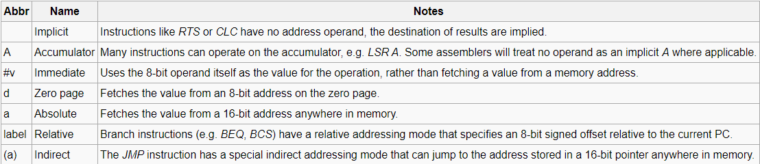

#### 

#### Instructions

Instructions are communicated to the CPU via opcodes. These opcodes represent an instruction and the addressing mode the instruction should use to get the data needed.

#### Memory map[3]

|  |  |  |
| --- | --- | --- |
| Address range | Size | Device |
| $0000-$07FF | $0800 | 2KB internal RAM |
| $0800-$0FFF | $0800 | [Mirrors](http://wiki.nesdev.com/w/index.php/Mirroring) of $0000-$07FF |
| $1000-$17FF | $0800 |
| $1800-$1FFF | $0800 |
| $2000-$2007 | $0008 | [NES PPU](http://wiki.nesdev.com/w/index.php/PPU_registers) registers |
| $2008-$3FFF | $1FF8 | Mirrors of $2000-2007 (repeats every 8 bytes) |
| $4000-$4017 | $0018 | [NES APU](http://wiki.nesdev.com/w/index.php/APU) and [I/O registers](http://wiki.nesdev.com/w/index.php/2A03) |
| $4018-$401F | $0008 | APU and I/O functionality that is normally disabled. See [CPU Test Mode](http://wiki.nesdev.com/w/index.php/CPU_Test_Mode). |
| $4020-$FFFF | $BFE0 | Cartridge space: PRG ROM, PRG RAM, and [mapper](http://wiki.nesdev.com/w/index.php/Mapper) registers (See Note) |

We use memory in the form of a char Array because it makes it easy to address using the cartridge addressdata.

#### Interrupts[4]

#### Pins[5]

## APU

### Beschreibung

Die APU kümmert sich um das Processing vom Audio.

## PPU

## Memory

## Bus

# Implementation Plan

All our addresses and data are represented by unsigned integers of the needed size. More specifically by the types **uint8_t and uint16_t**.

As we progressed through the project it became apparent that we had to use unsigned integers, so reading and writing data, addressing and reading flags and registers does not bug.

## CPU

### Registers

Registers are represented by uint8_t variables, except for the PC, which is a uint16_t. These variables are public and referenced directly.

### Opcodes

Opcodes give us a key that tells us three pieces of information[6]:

* Addressing Mode
* Instruction
* Clock Cycles

The addressing modes and instructions are implemented as functions, and clock cycles as an Integer. These three parts are put together in a structure, which is then put into an array and referenced by the opcode. This array has a length of 256 elements. The functions are referenced by function pointers.

Instructions must properly set the flags and must work properly with the addressing modes given. We will implement ways to test them easily, bug fixing will be a focus while developing the emulator.

All the functions are void and save needed data into object variables such as the variable “data”.

### Running the CPU

While running, the CPU will read the address given by the Program Counter and will save the Byte it got to the opcode variable. Then the EXC_OP() function is called to read the opcode and execute the instruction with the needed addressing mode. The instruction uses the address parameter determined by the addressing mode function. The program counter is then set correctly for the program to continue.

## Memory

The Memory is part of the bus because it can only be accessed by the bus. It consists of an uint8_t array which currently has a length of 0xFFFF. The elements in the array are accessed by the read/write methods of the bus, which gets an address to read/write that represents the index in the array.

## Bus

Read/Write functions for 8 Bit data with 16 Bit addresses as parameter.

1. http://wiki.nesdev.com/w/index.php/CPU_unofficial_opcodes
2. http://wiki.nesdev.com/w/index.php/CPU_addressing_modes
3. http://wiki.nesdev.com/w/index.php/CPU_memory_map
4. http://wiki.nesdev.com/w/index.php/CPU_interrupts
5. http://wiki.nesdev.com/w/index.php/CPU_pin_out_and_signal_description
6. http://www.obelisk.me.uk/6502/instructions.html